CASCADE FIELD & sTREAM CLUB

PO BOX 424 Facebook: Cascade Field & Stream Club

CLE ELUM, WA. Email: stevecin984@msn.com

98922 President Mark Bennett - 509-670-1464

NEWSLETTER ISSUE 33 August, 2015

RANGE: An on-line seminar on how to implement/use our State grant was attended by Steve & Cindy Rogers, Mike Cox, and Duane Fluent. Lots of details involved, but workable. We will receive a contract next week. When signed and returned we will be advised of the date we can actually start our projects on the range. The projects are mainly infrastructure, noise abatement, safety, and ADA access.
As most of you know, the multi-lock gate system is history, thanks to an agreement with Eric Melbardis at the wind farm. The one lock is opened with the current "annual member" combo. I know of at least one life member who forgot the annual combo and had to call for help. If you don't know the combo just shoot me an email or call at 509-674-8653. We will look for a lock that works better and with a tether so it won't be dropped and damaged. Dick Wolf was given the go ahead to install a drop pin on one side of the double gates to keep one from swinging all the way open in the wind.
WEBSITE: With the help of new Life Member, Calvin Tang, we are up and running at: www.cascadefieldandstream.com I would ask that members check it out and forward any suggestions/issues/ideas via the contact form. It is new and open to change. We will try to get a photo and bragging rights page included. One suggestion was to have an NRA membership form available to print. I think I got it on there now.
BANQUET: Annual fundraiser raffle prizes are being decided on. We are looking at a Mossberg shotgun combo (two barrels) and a .30-06 rifle (Cle Elum Farm & Home), a fly rod, reel and case (Troutwater Fly Shop), and some type of archery equipment (compound bow, targets?). We will make final decisions at the Board meeting on the 17th. Tickets should be printed and ready for sale by Sept. 1st. The banquet will be on Saturday, February 27th, 2016, at the Putnam Centennial Center.
MISC: The next Hunter Education class starts on August 17th and the range will be closed Saturday 22nd from 8 am to about 2 pm. If there are any parents interested in becoming an instructor please get ahold of our Chief Instructor, Trevin Roletto at 253-569-1008 in South Cle Elum, or Aaron Garcia in Yakima at 509-575-2740. Sign up for classes on-line at: www.wdfw.wa.gov/hunting/hunter education.
Bob Davis opened a discussion on a possible indoor archery/.22 range. This would be a great topic for a future grant and we would like to see some folks form a committee to work on it.
Brothers N Arms will be conducting firearms training classes at the range off and on and will not need to have the range closed. Their four instructors are now club members. Check their website or at the shop in E'burg if interested in a class.

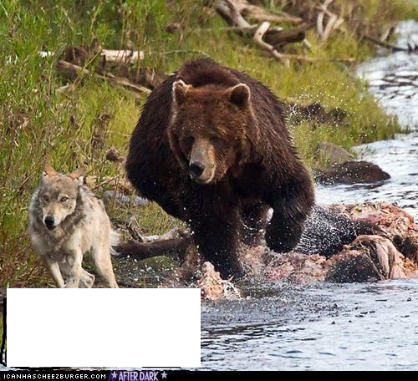
That's it!! This is how we will control the wolf population - release grizzlies into the Teanaway.
Sorry, I blocked out what the wolf was saying, might offend.
Stay Vigilant
Steve Rogers, V.P.
509-674-8653

