CASCADE FIELD & STREAM CLUB
Website: www.cascadefieldandstream.com
Email: steve@cascadefieldandstream.com
Facebook: CascadeFieldandStreamClub

President Mark Bennett - 509-670-1464

PO BOX 424
Cl;e Elum, Wa. 98922

NEWSLETTER ISSUE 38 February 2016

Since we've had so many new members lately I'm going to repeat some of the last newsletter:

RANGE: We've had lots of new members asking what we have in the hopper for plans at the range. Past newsletters with a lot of the info are available at the website. We did get a grading permit, so, when available, we hope the Operating Engineers School will still be able to do some major earth moving work for us (ie. widen the rifle range, construct a maintenance road across the north side of property, construct a road down to the proposed Law Enforcement training range). Our State grant will need to be amended in consideration of the changes for a single, long shooting shed at the rifle range rather than a bunch of smaller sheds (Blue prints provided by Steve Senger). Part of the grant will include parking and ramps required under the Americans with Disabilities Act. The pole building over the storage containers was built to protect the containers from the weather. We plan to enclose the building to have a small meeting room in the middle. We have purchased a heavy-duty generator which will provide power for the meeting room and, eventually lights at the rifle/pistol ranges. The target committee has purchased a huge amount of steel and other targets which should last us for many years.
BANQUET/RAFFLE: Get Raffle tickets by sending us a check or money order with the number of $5 raffle tickets you want (CF&S, PO Box 424, Cle Elum 98922). Or, shop at Owen's Meats, Cle Elum Farm and Home, Cle Elum Hardware, Reliable Auto, Mike's Tavern, Glondo's Sausage, 3 Forks Ammo, Carek's Meats, Grizzly Safe Co., Kittitas County Trading Post, Brothers N Arms, Bookkeeping, Etc., and Trout Water Fly Shop, and pick up some raffle tickets. Contact Mark Bennett (509-670-1464) for raffle tickets to sell. Banquet tickets are now available at $35. Contact us via mail to purchase or go to Reliable Auto, Cascade Door and Remodel/Bookkeeping, Etc., or Grizzly Safe Co. for tickets. Check out the website for a look at the 2016 banquet flyer developed by our own Tom Saffle - it is a beautiful piece of work. We now have 7 tables reserved. Better hurry to get your dinner tickets!
SCHOLARSHIP: The scholarship committee met to work out some details and qualifications for the new scholarship we will offer seniors at CE/R and Easton High Schools. The scholarship will be worth $1000 and that will be paid for by a portion of the proceeds from the annual raffle. If this is successful we will probably look at a second scholarship in the future.
EASTON ARCHERY CLUB: The CF&S Club supports the Easton Jaguar Archery Team run by Cece Bada at the Easton School. This year we voted to increase our support to $500. *For those club members who purchase propane from AmeriGas, the company has agreed to give $.02 for every gallon of gas purchased. That can add up pretty quickly. Pass this on to any family or friends that use AmeriGas. The Team needs $2000 to cover the cost of traveling to the 2015-16 NASP Archery Tournaments. How to help: When you purchase propane from AmeriGas make a copy of your receipt and drop it off at Easton school or send it to: Easton School, c/o Cece Bada, PO Box 8, Easton, Wa. 98925. Questions? Call Cece at 509-656-2317 x310.

OTHER:
We had a great meeting Monday with 30 members present. Jay Huggins won the 50/50 drawing.
We received a very nice "thank you" letter from Chelan County HOPE for the great donations of clothing, boots, etc. that our club members ponied up for the survivors of the Chelan County fires last August. Thanks again to Jerry Rockey for organizing this and hauling the items up to them.
I'll make another plea for donations (either items or cash to help cover the costs of purchasing auction/raffle items) for the annual auction/fundraiser coming up on Feb. 27th. We have had some very generous donations coming in and can always use more. We have purchased several firearms for raffles - although we got some very good discounts from Max Keeton at Farm & Home, it still costs a lot of money to provide these items. Club members Joe and Jan Schiemer applied for and received a great donation from Cabella's in Union Gap. We picked these up yesterday in Union Gap - Lg. tackle bag, very nice day pack with tackle boxes, and a Director's Chair. Thanks to Joe and Jan, and to Curtis Frisbie at Cabela's. (Be sure to shop there and look Curtis up and thank him).
The shooting range has been pretty well snowed in lately! Please be patient and hope for an early spring! We're not sure what to do about the SaniCan - the top is caved in due to snow sliding off the pole building roof (yup, we didn't think about that in time). When possible we will get it moved in under the roof. I hate to ask - But, if anyone has a plow, blade, tractor that can push snow/ice, and has a little time, we really need a place to park a vehicle at the rifle/pistol range. The windfarm contracts their plowing and only have a single lane open so they can access the windmills. It's been pretty tough to get in and use the range.
Below is a ballot for the upcoming officer election at the annual banquet/auction. Nominations are still open if anyone has someone in mind to add - just write a name in.
How to vote: Print and cut out this ballot, mark it appropriately, and mail it in to the club at:
CF&S, PO Box 424, Cle Elum, 98922 (No later than Feb. 24th to be counted)
Or, bring it to the banquet, or grab a club officer and hand it in.
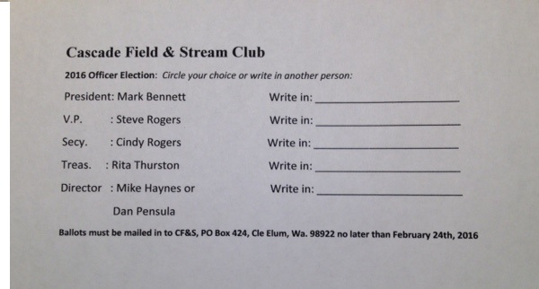
Have a great February and hope to see you at the range soon. Steve Rogers, V.P.

