CASCADE FIELD & sTREAM CLUB

PO BOX 424 website: www.cascadefieldandstream.com
CLE ELUM, WA. Email: steve@cascadefieldandstream.com
98922 Facebook: CascadeFieldandStreamClub

President Mark Bennett - 509-670-1464

NEWSLETTER ISSUE 48 january 2017

RANGE: A top official with DNR in Ellensburg has advised us that the Club will not be billed for the cost of fighting the fire on the range in August. He felt that we had covered our bases with our range rules prohibiting use of incendiary ammo and the club was not at fault. Also, we pay a "fire-fighting fee" in our annual property taxes which covers much of the expense. He did say that the flare gun shooter will be billed. The article in the paper, saying we would have to pay, was a result of "fake news" given to reporter Jim Fossett, not his fault.
Concerned member sent this:
"I went to the range Sunday. There was an individual in on the archery range that had left the gate unlocked and the combination showing. I did not get a plate number as we went into the rifle building and did not notice when he left. However, I did lock the gate behind us on the way in and the individual DID lock it when he left." LOCK THE GATE!!

The work party on Jan. 7th went well, considering that only 7 out of 450+ members showed up to work, and the back wall and sliding door on the rifle shed look great. Please remember to close and latch the door when leaving. In early spring we plan to install sound proofing materials to help muffle the noise.
BANQUET/RAFFLE: Annual raffle tickets @ $5 are available by sending check or money order to: CF&S, PO Box 424, Cle Elum 98922. The drawing will be at the banquet on Feb. 25th, 2017, at the Centennial Center.
We have the dinner tickets available @ $35 and the menu has been set (choice of prime rib or chicken) Only 150 tickets were printed so don't wait if you plan to attend. Order same as raffle tickets or come to a meeting. The banquet committee will meet every Monday until the event. If you have a group please ask for a reserved table as soon as possible, like yesterday!
We need donations for the auction and raffles. If you have an item, or a service, or even cash donation to help offset the costs of buying items - all would be appreciated. Also by yesterday.
OTHER:
Nominations are open for club officers. Nominations so far:
Pres. - Mark Bennett V.P. - ? Secy - Cindy Rogers Treas. - Rita Thurston
Board member - Dan Pensula (V.P. - I need a break. Time for new ideas - Steve)
Feel free to send nominations via email, phone, or come to a meeting. Meetings every Monday until the banquet.
Go to: washingtonvotes.org, check out bills being introduced, and contact your legislators about how you feel on various issues like gun control and increased hunting/fishing fees.
Doug Sargent won the 50/50 raffle.

2017 Banquet/Auction poster

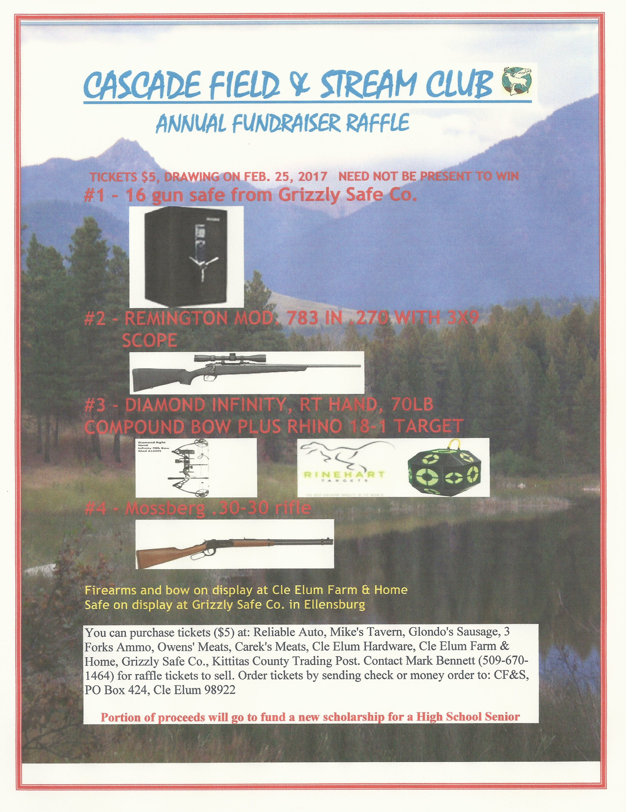2017 Raffle Flyer

