CASCADE FIELD & sTREAM CLUB

PO BOX 424 website: www.cascadefieldandstream.com
CLE ELUM, WA. Email: steve@cascadefieldandstream.com
98922 Facebook: CascadeFieldandStreamClub

President Mark Bennett - 509-670-1464

NEWSLETTER ISSUE 48 january 2017

RANGE: The DNR fire investigation is completed and we were told we would hear something by mid-December. Nothing as yet. We have submitted the KVFR bill to our insurance.
I repeat, again, "We are still finding the gate lock either hanging open with the combo showing, or closed with only one digit changed. Please remember to lock and spin the numbers so non-members can't figure out how to get in and use the range".
The new Range Rules signs have been installed on the rifle and pistol ranges, and are now printed in the latest version of the membership application, and on the back of all new membership cards. Just to re-stress, "No incendiary ammo" (ie. flare guns).
BANQUET/RAFFLE: Annual raffle tickets @ $5 are available for sale at Reliable Auto, Mike's Tavern, Glondo's Sausage, 3 Forks Ammo, Owens' Meats, Carek's Meats, Cle Elum Hardware, Cle Elum Farm & Home, Grizzly Safe Co., Kittitas County Trading Post. Contact Mark Bennett (509-670-1464) for raffle tickets to sell. Order tickets by sending check or money order to: CF&S, PO Box 424, Cle Elum 98922. The drawing will be at the banquet on Feb. 25th, 2017, at the Centennial Center.
We now have the dinner tickets available @ $35 and the menu has been set (choice of prime rib or chicken) with the Centennial Center staff. Only 150 tickets were printed so don't wait too long.
OTHER:
Work party this Saturday, Jan. 7th, 9 am, to finish the back wall of the shooting shed building. It may be a little chilly so dress for it. Also, yes it is loud inside the shed. We plan to add sound muffling material.
Gate combo has changed. If you have not yet renewed your membership, git 'er done if you want to use the range. Membership application attached - be sure to sign it so you certify you're not a terrorist or planning to overthrow the government as that would preclude you from membership.
Nominations are open for club officers. Nominations so far:
Pres. - Mark Bennett V.P. - ? Secy - Cindy Rogers Treas. - Rita Thurston
Board member - Dan Pensula
Feel free to send nominations via email, phone, or come to a meeting.
The 50/50 raffle pot was up to $54. Skye Osiadacz won the drawing and took home $27.

2017 Banquet/Auction poster

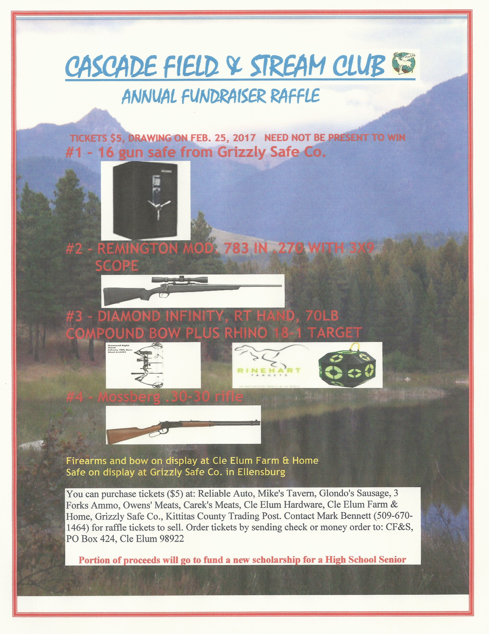2017 Raffle Flyer

