CASCADE FIELD & sTREAM CLUB

PO BOX 424 website: www.cascadefieldandstream.com
CLE ELUM, WA. Email: steve@cascadefieldandstream.com
98922 Facebook: CascadeFieldandStreamClub

President Mark Bennett - 509-670-1464

NEWSLETTER ISSUE 39 March 2016

FIRST OF ALL, WOW, WHAT A BANQUET WE HAD!!!
BANQUET/FUNDRAISER: On Saturday evening, Feb. 27th, we had a record number of club members and other supporters show up for our 20th annual fundraiser banquet at the Centennial Center. I'm pretty sure we had a record net income for the night, too (I feel it in my bones). It was a lot of fun to see most of the usual attendees there laughing, eating (Yummm), and spending money for a very good cause. Thanks to everyone who gave up their evening to spend it with friends and family. And, thanks to all those who helped with donations. You will see your names in the paper very soon.
We had quite a few new members sign up at the banquet. And, Mr. Lon Lewis was the highest bidder for the Life Membership being offered on the live auction - Thanks, Lon!! The elk antler lamp donated by Life Member Al Lang went for over $600, the highest single item on the auction. Thanks to Al and thanks to Mandi Guiley for bidding so well! Our new auctioneer, Roger Swansen, did a terrific job!
I apologize for my obnoxiousness with the microphone! Geez, I could barely speak the next day.
RANGE: Now that that's over, and as soon as the ground dries a little more, we will begin to put that money to good use. I hope that the range will be closed several days this spring due to grading and construction work in progress! There will be a work party on May 21st at 9 am (More info later). Regarding the state grant, we don't need to do an official amendment to build a single long shooting shed. But, a new hoop - we do need it certified by an NRA approved engineer, to say it meets NRA standards. We can do that.
RAFFLE: It looks like we did very well on the annual raffle. That will help fund our new $1000 scholarship for an Upper County High School Senior. The rest goes into our general fund for range projects.
OFFICER ELECTION: It also looks like you are all stuck with the same Officers for another year. For all intents and purposes it was unanimous. Thanks from all of us for your support and confidence in us to keep the club going. President Mark Bennett, V.P. Steve Rogers, Treasurer Rita Thurston, Secretary Cindy Rogers, and 3 year Director Mike Haynes.
BREAKING NEWS: We received a message this week from our contact with the Operating Engineers School east of E'burg. The news was not good - according to the Manager/Foreman they will no longer be doing "off-site" projects. They have a very demanding training schedule and many obligations. That means all their training will be done on their work site off Vantage Hiway. I traded emails with their union President, Life member Sean Jeffries. He advised we should not give up all together as there may be a chance for some work in smaller portions at some time in the future. Or, maybe by another contractor. Sean came to the meeting last night and gave us a little more insight and ideas.
President Mark Bennett asked me to put this notice in the newsletter and ask for any members and/or friends with heavy equipment to get in touch with us to see if we can't salvage some of this earthwork that needs to be done. Most of what we need done cannot be done with Bobcats or farm tractors. I guess our priorities would be widening the rifle range and getting a road built into the law enf. Range. We already went through the hoops to get a grading permit from the County so we are good to go if we can get equipment. Thanks to a huge effort by many people, including Club members at Cruse & Assoc. and Engineer Trevin Roletto, we have very good plans drawn up and ready.
OTHER: Rita and the Davies' are working on details for the scholarship. Good job! We started talking about the Kid's Fishing Derby on June 11th and we need some volunteers to help set it up. Dan and the target committee are chomping at the bit to get busy at the range. WDFW's Aaron Garcia is hosting a turkey hunting clinic at the range on April 10th. It will feature expert caller/turkey hunter extraordinaire Rich Mann. Great meeting last night with 31 members. Rapidly approaching 300 new/renewal memberships. And, Wes Clogston became a Life Member at the meeting.
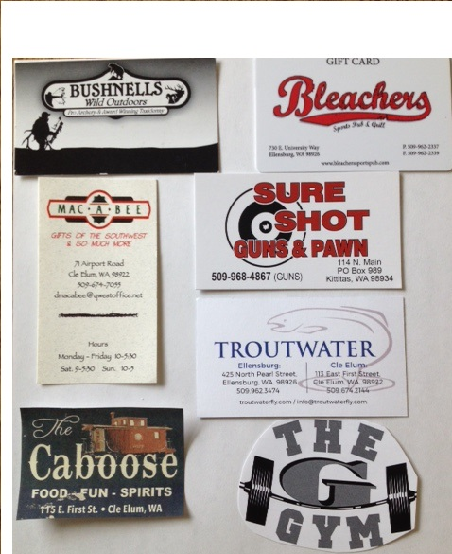
Be sure to shop at these local businesses that support our club. There are many more but I ran out of room this time.
Steve Rogers, Newsletter Editor

I hope this wasn't anyone from our banquet!

