CASCADE FIELD & sTREAM CLUB

PO BOX 424 website: www.cascadefieldandstream.com
CLE ELUM, WA. Email: steve@cascadefieldandstream.com
98922 Facebook: CascadeFieldandStreamClub

President Mark Bennett - 509-670-1464

NEWSLETTER ISSUE 50 March 2017

RANGE: Here's hoping the snow quits soon and we can get out and use the range. We've been in touch with our asphalt paving outfit and we are on his spring schedule for paving the pathways and ADA parking pads. Much of this will be covered by our State Grant. We still have some work to do on the rifle shed (sound and safety baffling) and, as soon as we have a structural engineer (anyone know one who may help us out?) sign off on the safety features we can request some reimbursement from the Grant. We are working with a contractor to build a shelter for the pistol range and still waiting to hear from the wind farm bosses as to whether we can build anything on the archery range.
BANQUET/RAFFLE: In spite of a smaller crowd we had a great banquet. Everyone was having fun, bidding was brisk and hot thanks to our auctioneer Roger Swansen, and the meal was unbelievable thanks to Chef Frank Schuchman and the Centennial Center Crew. It was probably our best "end-of-winter party" ever and our supporters did a great job. Thanks to all who attended and all of our contributors - We had some fantastic auction/silent auction items available. Thank you ads have been submitted to the newspapers.
The annual raffle was nearly sold out. We only printed 1000 $5 tickets. The winners were: .270 rifle - Bruce Mueller, Issaquah, Gun Safe - Patti Eidemiller, Cle Elum, Archery package - Herb Jones, Cle Elum, .30-30 rifle - Patti Eidemiller, Cle Elum Congratulations to all and thanks for buying tickets.
MEETING: We had a general membership meeting Monday night with 22 members present. A representative from "American Rivers" gave a presentation on the Wild and Scenic Rivers designation plans for the Upper Cle Elum, Waptus, and Cooper Rivers and, with the help from KC Commissioner and club member Paul Jewell, explained how the Yakima Basin Integrated Plan works in regard to salmon and other fish habitat protection and in-stream flows into the future. We were shown slides of the planned sockeye passage plan for Cle Elum Dam and Lake.
There was much discussion on the banquet and raffle, upcoming projects, and the Kid's Fishing Derby in June. President Mark Bennett explained how the earth-moving project went at the range that day - it didn't. The CAT became buried in mud and the project was called off until May. Gotta love that Caliche clay in the spring! Also, Mark hoped to get the County Building Inspector up to certify the rifle shed this week.
We had a new Life member sign up and he volunteered to step in to fill the vacant Board of Director's Trustee seat after members voted to remove the former Trustee due to lack of attendance and the resulting lack of a quorum at meetings. The new Trustee is Scott Warren, owner of the Old #3 in Ronald. He is a very active trap shooter and would like to be involved in development of our future trap range.
Club member Doug Sargent advised he has completed the NRA Range Safety Officer training and is willing to take on the job of Range Master. This will be especially important during special events and when the public is eventually allowed in to use the range. Steve Douglas won the 50/50 drawing.

OTHER NEWS:
Officer Election Results:
Pres. - Mark Bennett V.P. - Larry Haywood Secy - Cindy Rogers Treas. - Rita Thurston
Board Trustee - Dan Pensula (3 year term)
Club members Joe and Jan Schiemer have been in touch with Cabela's regarding our fishing derby and they may provide new fishing poles for the kids at the derby.
The Scholarship Committee will soon begin plans for the 2017 $1000 Scholarship to be granted to an Upper County High School Senior. We have received regular updates from last year's winner, Holly Terrell, who is studying engineering in Idaho.
We are an NRA recruiter and, thru the club, you can still get a Life Membership for $600 through Mar. 31st.
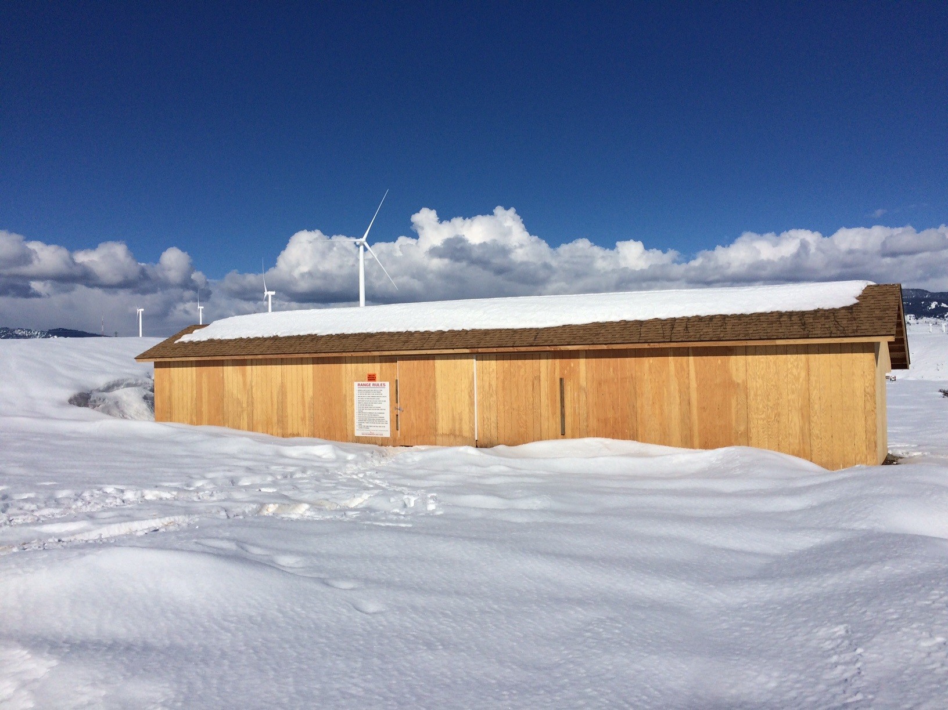
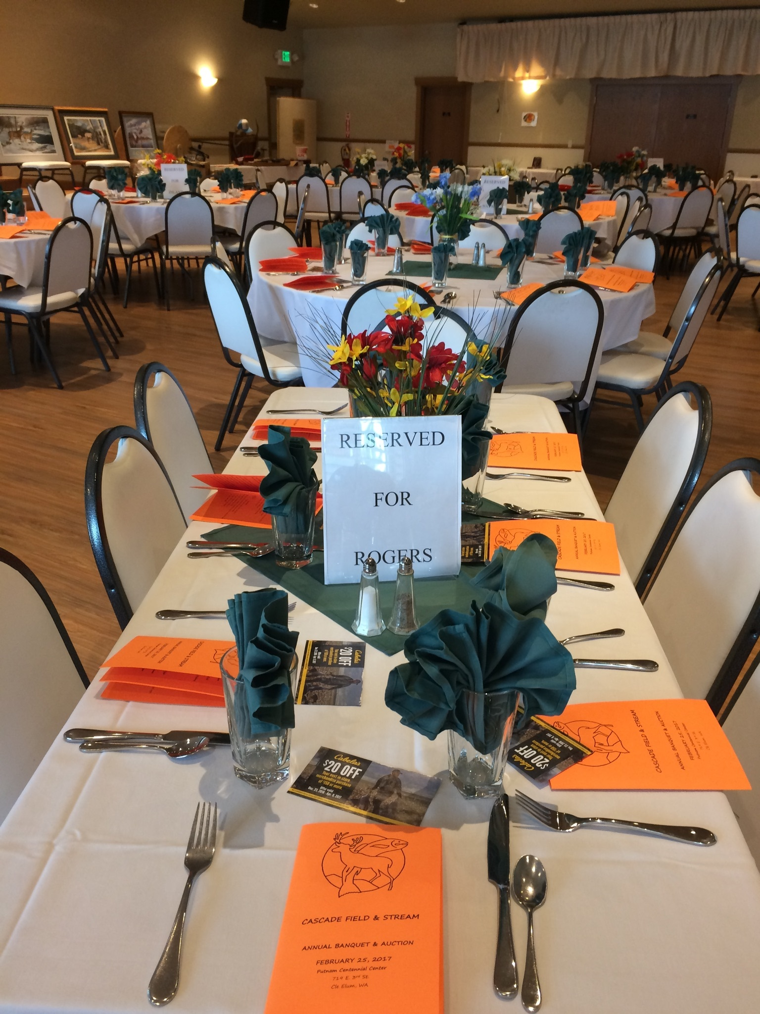
Rifle shooting shed Banquet table setup
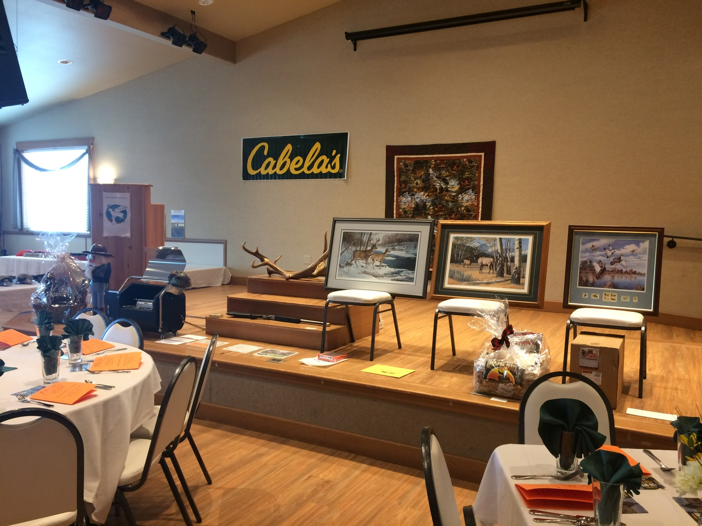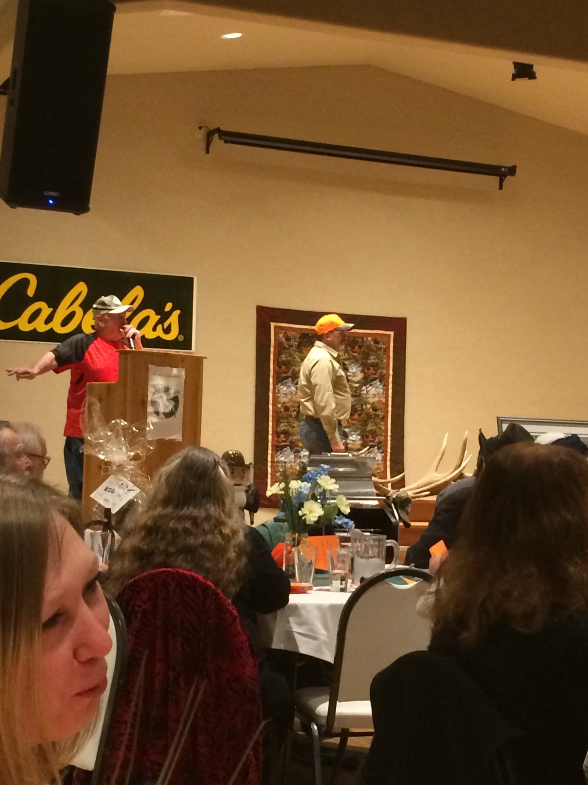
Auction items Auctioneer Roger Swansen
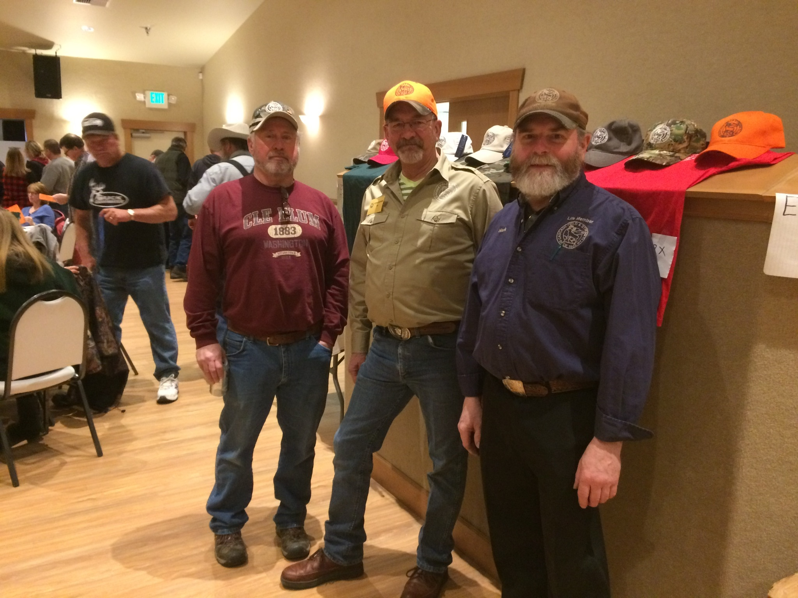 Joe, Steve, the other Steve, Mark
Think Spring. See ya at the range. Steve Rogers, Newsletter Editor

