CASCADE FIELD & sTREAM CLUB

PO BOX 424 website: www.cascadefieldandstream.com
CLE ELUM, WA. Email: steve@cascadefieldandstream.com
98922 Facebook: CascadeFieldandStreamClub

President Mark Bennett - 509-670-1464

NEWSLETTER ISSUE 41 May 2016

RANGE: There will be a work party on May 21st at 9 am. We're going to try to get the generator ready to install, amongst other chores. Any members and/or friends with heavy equipment (large bulldozer would be great) get in touch with us to see if we can't salvage some of this earthwork that needs to be done. Most of what we need done cannot be done with Bobcats or farm tractors. Looks like our priorities would be widening the rifle range and getting a road built into the proposed law enforcement range. Since we already have a grading permit from the County we are good to go if we can get equipment. Bobcats and smaller tractors will help spread more gravel on the pathways. We may try to build some new targets stands and erect a "dueling tree" target. Stay after for a BBQ lunch. Bring a side dish if you can - PLEASE!!
There was some discussion about a solar powered entry gate with keypad - looks like a durable system would cost around $11,000. We'll look into grants (NRA, Friend of the NRA, etc.) for help with this and with a cement pad for the rifle range shooting shed. President Mark has arranged for MacIntosh Pole Buildings to erect the shooting shed (10' x 70') starting in August. The Club will be paying for this building and we will submit an amendment to the State regarding the RCO Grant to cover the other infrastructure work needed (parking pads, pathways, and access for wheelchairs, shooting sheds for the pistol and archery ranges).
SCHOLARSHIP: This is our first time to offer a $1000 scholarship for any senior at CE/R, Easton, or Swiftwater Learning Center. We have had only 2 applicants and the deadline for application is/was May 5th.
OTHER: We've started work on the Kid's Fishing Derby on June 11th and we have a few new volunteers to help set it up. The WDFW permit is already handled and we will need members to try to collect donations for prizes (cash or items). Tom Saffle revised our Derby Flyer for 2016.
Great meeting Monday night with 25 members. Membership is close to 330 new/renewal memberships since the first of the year. Treasurer Rita advised we have a total of $149,271 in the bank, including CDs. Our final net from the banquet was $12,163 and we are bringing in around $800 to $1,000/month in memberships.
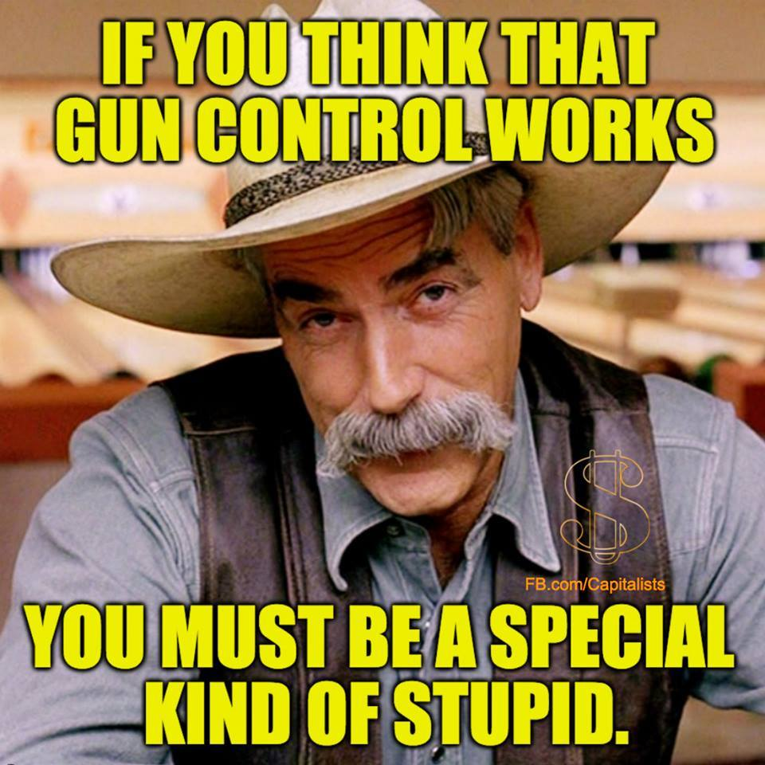
Have a great month.
Steve Rogers, Newsletter Editor

