CASCADE FIELD & sTREAM CLUB

PO BOX 424 website: www.cascadefieldandstream.com
CLE ELUM, WA. Email: steve@cascadefieldandstream.com
98922 Facebook: CascadeFieldandStreamClub

President Mark Bennett - 509-670-1464

NEWSLETTER ISSUE 47 November 2016

Donald Trump's historical win will be a terrific win for firearm owners in this great country. We will still need to be vigilant in our various States to stop anti-gun legislation!

RANGE: According to the lead investigator with DNR, the fire investigation is completed and the report is being forwarded to their upper level management folks for a decision on recovering fire suppression costs. We did received an invoice from Kittitas Valley Fire & Rescue for $6700, for response by Fire Districts 1, 2, and 7. According to an article in the Daily Record there will be no criminal charges filed for the cause of the fire.
The rifle range shed is built and the concrete floor poured. We are planning a work party for November 26th to put up the siding and rear-entry door on the shed, among other projects. Mark your calendars.
I repeat, "We are still finding the gate lock either hanging open with the combo showing, or closed with only one digit changed. Please remember to lock and spin the numbers so non-members can't figure out how to get in and use the range".
BANQUET/RAFFLE: Annual raffle tickets are available for sale at Reliable Auto, Mike's Tavern, Glondo's Sausage, 3 Forks Ammo, Owens' Meats, Carek's Meats, Cle Elum Hardware, Cle Elum Farm & Home, Grizzly Safe Co., Kittitas County Trading Post. Contact Mark Bennett (509-670-1464) for raffle tickets to sell. Order tickets by sending check or money order to: CF&S, PO Box 424, Cle Elum 98922. The drawing will be at the banquet on Feb. 25th, 2017, at the Centennial Center.
OTHER: The Bitterbrush planting was a great success and, a month later and after the rains, most of the plugs put in the ground are still alive. Hopefully the seeds will sprout in the spring. Thanks to all who helped to restore our deer habitat.
50/50 Raffle: We had 14 members at the meeting Monday in spite of the Seahawks game. The raffle pot grew to $22 and Jerry Rockey won the drawing for $11. The other half goes into the pot for the annual drawing at the banquet. The more meetings you attend, the more times your name is in the hat.
From Wes Jones: I am looking for the replacement receiver side cover plate for a mini 14 that has a machined raised boss and a threaded screw hole that will let me install a scope on the side of the receiver of this gun. Is there a way to find out if any club members might have this side plate and if not do they know where I might look? Thanks, Wes (wesjones98922@yahoo.com).
From Larry Fuller: Do you know anyone in the club who can use a half box of 9 shot 28 gauge shells - a friend gave them to me and I don't have a 28 gauge shot gun. Larry (larryfuller5@gmail.com).

WORK PARTY: Nov. 26th, 9 am at range. Bring food, water, hammers and/or power drills with screwdriver heads.
In an effort to preserve the targets on the pistol range it has been decided to no longer allow rifles or any center fire rifle cartridges on the pistol range. A new sign is being developed at this time. Also, new range rules signs are being developed.
At the December 5th general meeting the Club will provide Christmas cookies and coffee. Merry Christmas. 🎅

2017 Banquet/Auction poster developed by club member Tom Saffle

New rifle shed with floor
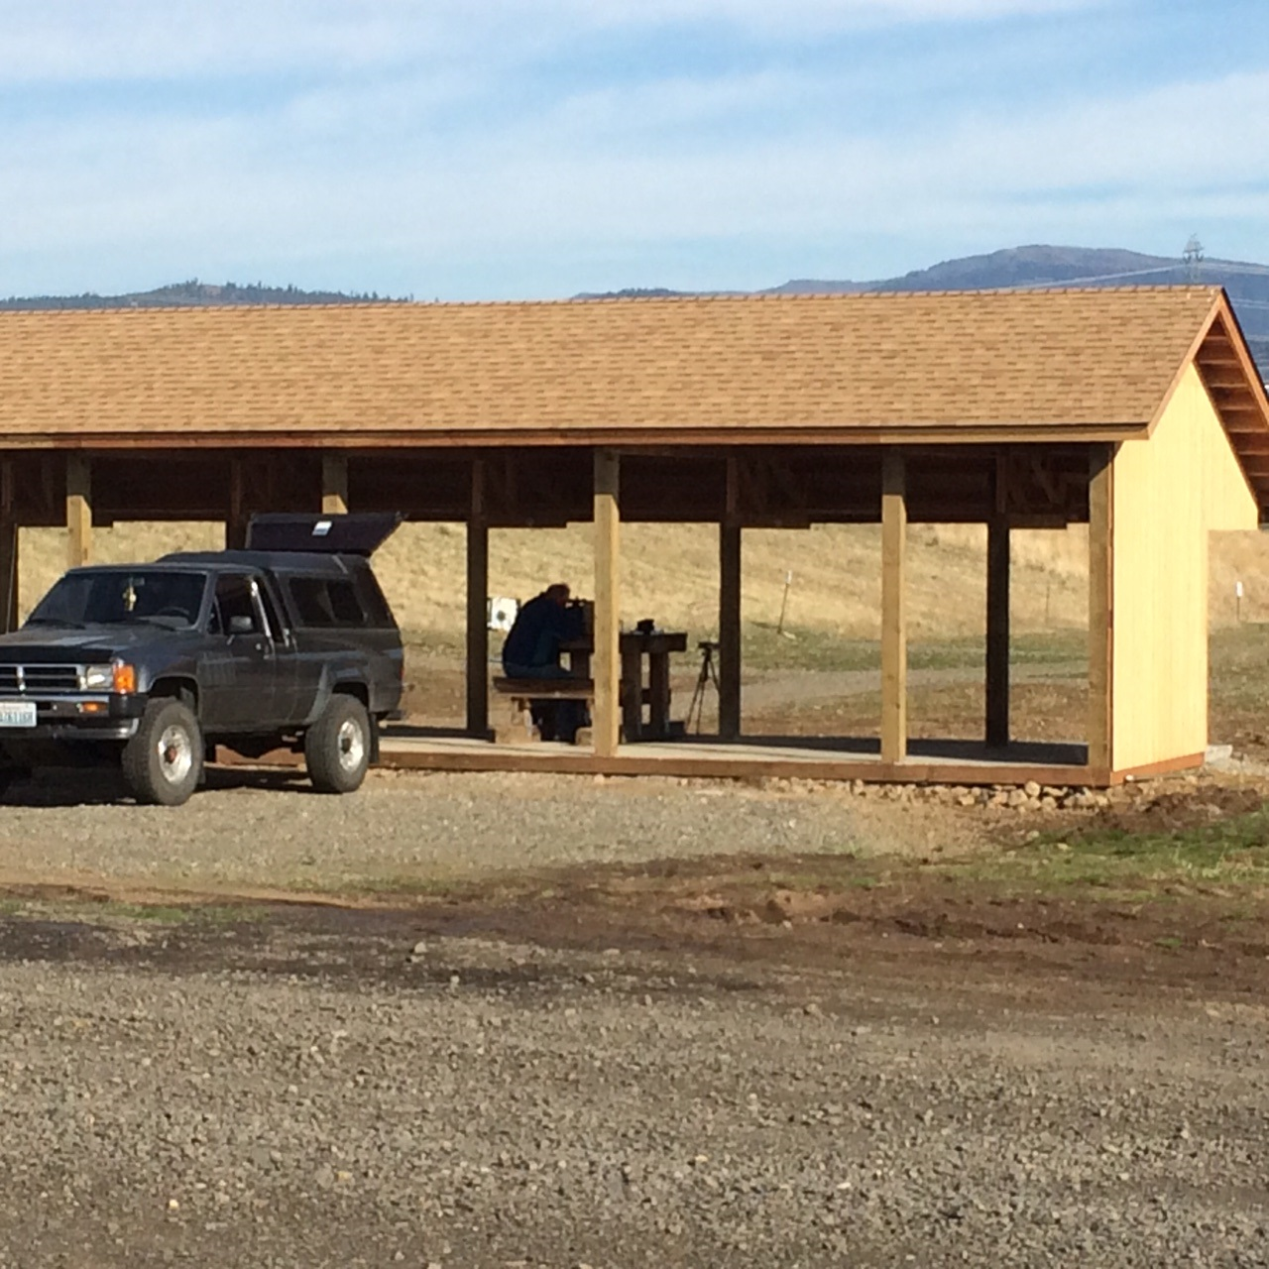

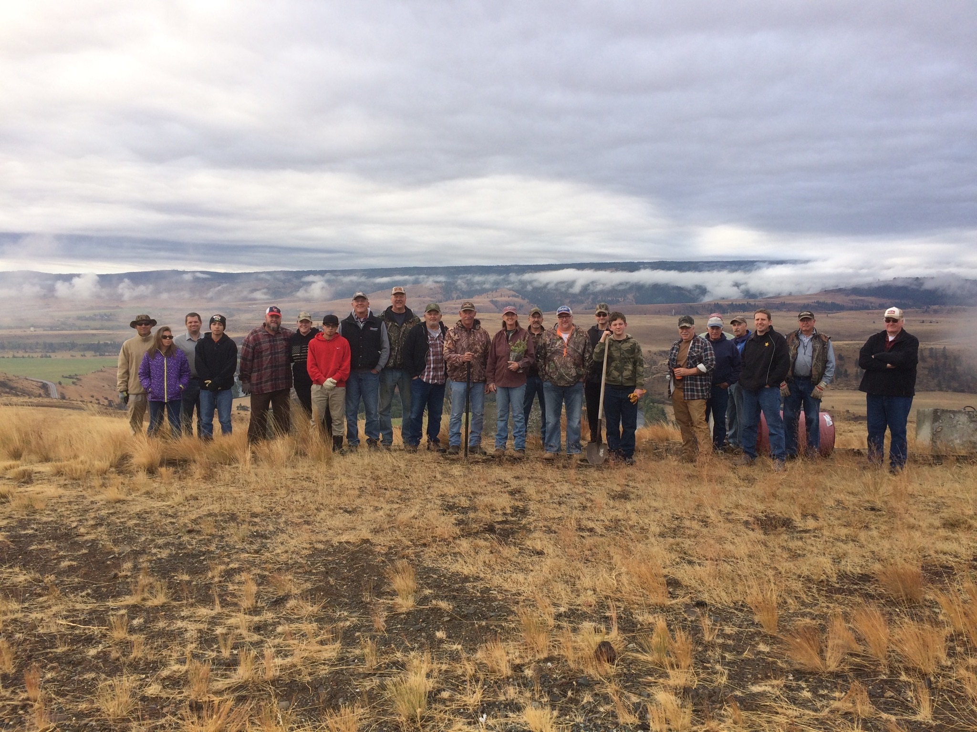
October 2016 Bitterbrush planting crew
Hope your Fall outdoor activities were successful and rewarding. Keep up the good fight. Steve

